December ushers in winter holidays such as Christmas, Kwanza, and Chanukah. It is also a time when families gather in the warmth of their homes. Throughout the month, our thoughts and actions turn toward charity and peace. Christmas is an annual festival commemorating the birth of Jesus Christ, observed primarily on December 25 as a religious and cultural celebration among billions of people around the world.

**Note-worthy Dates**

Wear Christmas Socks on 12/2 (National Sock Day)

National Stretching Day – Participate in stretching Movements 12/11

Come visit the St Luke’s Outreach Ministries Bus on 12/17

Our Christmas Celebration Potluck will be 12/17. Bring your favorite dish.

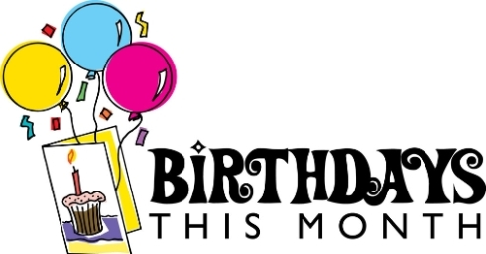

December 2nd– Irene Glashoff

December 8th – Elizabeth Jordan

December 16th – Gertrude Flournoy